>>> Landing Page - Renato's Portfolio

>>> Figma Design, Access the FIGMA project:

Page Link, click here (Case don't work, at the end document have complete URL.)

>>> About

It landing page project was create with FIGMA, the page focus is are shows design skills and through that page
to convert clientes too

>>> Tecnologies used

FIGMA - For design and prototype

>>>Images from develop environment and the page created:

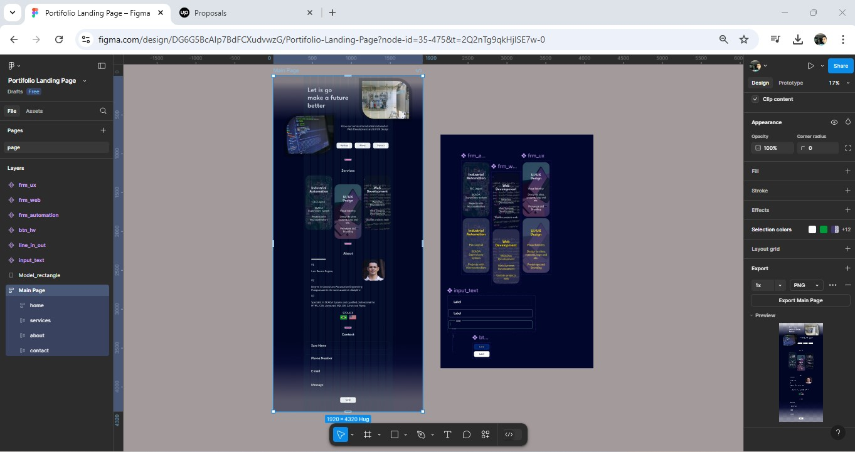
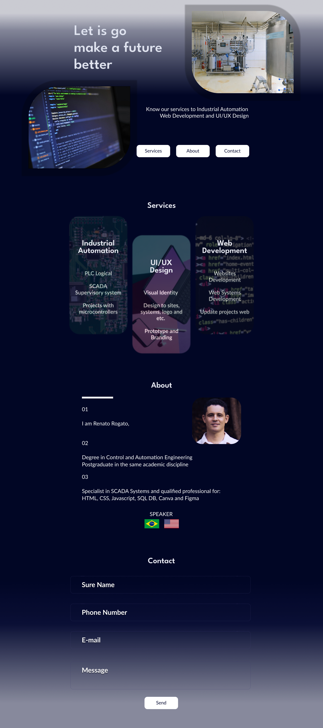
Complete URL Project

https://www.figma.com/proto/DG6G5BcAIp7BdFCXudvwzG/Portifolio-Landing-Page?node-id=35-475&starting-point-node-id=35%3A475&t=6W2ylh5LJvhaosb5-1

